**Assignment No:2**

Practical Exercise: Constraint Satisfaction Problem (CSP)

**1) Problem Statement**

Implement a solution to the "Missionaries and Cannibals" problem, a classic example of a Constraint Satisfaction Problem (CSP). The problem involves three missionaries and three cannibals on one side of a river, along with a boat that can carry up to two people. The goal is to safely transport all missionaries and cannibals across the river without ever leaving more cannibals than missionaries on either side of the river.

**2) Libraries Used**

Python:  
1. Basic data structures (lists, tuples) are used to represent the state of the problem.  
2. Collections: For managing the queue or stack required in BFS or DFS implementation.  
3. Numpy (optional): Can be used for array manipulation if needed.

**3) Theory**

Constraint Satisfaction Problems (CSP) are mathematical problems defined by a set of objects whose state must satisfy several constraints or limitations. The "Missionaries and Cannibals" problem is a CSP where constraints include not leaving missionaries outnumbered by cannibals on either side of the river.  
  
The goal is to explore the possible valid moves (states) while satisfying these constraints. A state consists of the number of missionaries, cannibals, and the position of the boat, and valid moves involve moving one or two individuals at a time while maintaining the constraints.

**4) Methods**

The solution is implemented using the following steps:  
1. **State Representation**: A tuple (missionaries_left, cannibals_left, boat_position) represents the state of the problem.  
2. **Validity Check**: A function `is_valid_state()` is used to check if a state satisfies the problem constraints (i.e., not leaving more cannibals than missionaries on any side of the river).  
3. **State Transitions**: The possible moves (sending one or two people in the boat) are generated, and the validity of each new state is checked.  
4. **Search Algorithm**: A search algorithm (e.g., BFS or DFS) is employed to explore the state space and find a solution.

**5) Advantages and Disadvantages**

- **Advantages**: CSP techniques can efficiently solve problems with clear constraints and allow the exploration of all valid states. These methods are systematic and guarantee finding a solution if one exists.  
- **Disadvantages**: Depending on the size of the problem, constraint satisfaction can become computationally expensive, especially if the search space is large or poorly constrained.

**6) Diagram**

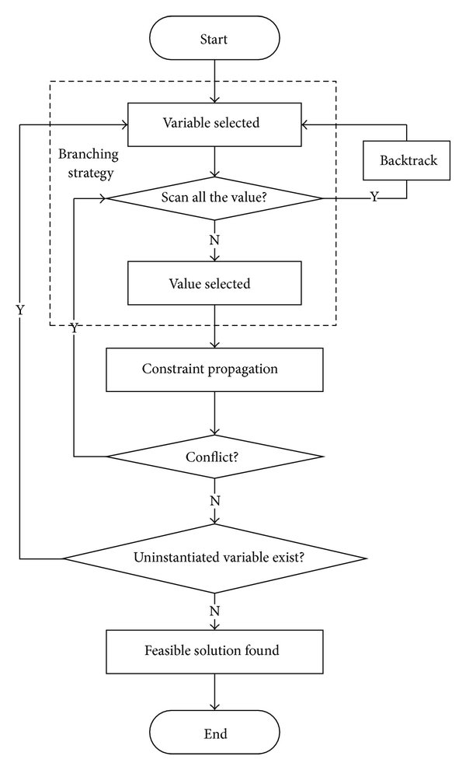

**FIG 1: CSP FLOWCHART**

**7) Conclusion**

The "Missionaries and Cannibals" problem showcases the power of Constraint Satisfaction Problems (CSPs) and search algorithms in solving real-world problems with defined rules and constraints. By representing the problem as a series of valid states and applying search algorithms, we can systematically explore the state space and find the solution while adhering to the problem's constraints.